Assignment 10
Title: Implementation of Phone Directory System using Hash Table and Separate Chaining

Name: Soham Ajit Puri
Roll. No: 04
Branch: CSDS_C1

Problem Statement: Design and implement a phone directory system that stores names and their corresponding phone numbers using a hash table. Handle collisions using separate chaining (linked lists). The program should support adding new contacts, searching for a contact by name, and deleting contacts efficiently.
Aim:
To design and implement a phone directory system that stores names and their corresponding phone numbers efficiently using a Hash Table data structure. The program should handle collisions using Separate Chaining and support fundamental operations such as adding, searching, deleting, and displaying contacts.
Objectives:
- To understand the concept of hashing and its application in efficient data storage and retrieval.
- To implement Separate Chaining as a method for handling hash collisions.
- To perform various operations on a hash table such as insertion, searching, deletion, and traversal.
- To understand how hash functions convert data into an array index for constant-time access.
- To demonstrate the practical use of hash tables in real-world applications like a phone directory system.
Theory:
A Hash Table is a powerful data structure that allows storing key-value pairs in such a way that each data item can be accessed efficiently, usually in constant time O(1) on average.The core idea behind a hash table is hashing, which uses a function called the hash function to map a given key (e.g., a name) to an index in an array (the hash table). Each element of the hash table is known as a bucket or slot.
When a key-value pair is inserted, the hash function determines where the pair should be placed. If multiple keys map to the same index (known as a collision), the hash table must handle it using a collision resolution technique.
Hash Function:
A hash function converts a string (key) into an integer that represents the index of the table.
In this program:
index= (∑ASCII values of characters in name) %TABLE_SIZE
For example, if TABLE_SIZE = 10 and the sum of ASCII values of the name “Soham” is 532, then the index is calculated as 532 % 10 = 2.
A good hash function distributes keys uniformly across the table to minimize collisions.\

- Collision and Separate Chaining:
A collision occurs when two different keys are mapped to the same index.
For example, “Amit” and “Riya” may both hash to index 4.
To handle such cases, Separate Chaining is used.
- Each bucket in the hash table stores a linked list of all key-value pairs that hash to the same index.
- When inserting a new contact, if the bucket already contains elements, the new contact is simply added to the linked list.
- During search or deletion, the linked list is traversed to find the required element.
This method ensures that no data is lost due to collisions, and all operations remain efficient even when multiple keys share the same index.
- Applications of Hash Tables:
- Database indexing
- Symbol tables in compilers
- Caching and lookup operations
- Password management and authentication systems
- Phone directories and contact management systems
Algorithm:
1. Initialize Hash Table
- Define a constant TABLE_SIZE = 10.
- Create an array of linked lists table[TABLE_SIZE].
- Each linked list node stores:
  - name (string)
  - phone (string)

2. Hash Function
- Initialize sum = 0.
- For each character c in the name:
  - Add its ASCII value to sum.
- Compute index = sum % TABLE_SIZE.
- Return index as the hash value.

3. Add Contact
- Input name and phone.
- Compute index using hashFunction(name).
- Go to the linked list at table[index].
- Traverse the list:
  - If a contact with the same name exists, update its phone number and print “Contact updated successfully.”
  - Otherwise, create a new contact node and append it to the end of the linked list.
- Print “Contact added successfully.”

4. Search Contact
- Input name to search.
- Compute index = hashFunction(name).
- Traverse the linked list at table[index]:
  - If a node with the given name is found, display name and phone number.
  - Otherwise, print “Contact not found.”

5. Delete Contact
- Input name to delete.
- Compute index = hashFunction(name).
- Traverse the linked list at table[index].
  - If the contact exists, remove it from the list and print “Contact deleted successfully.”
  - Otherwise, print “Contact not found.”
6. Display All Contacts
- For each bucket i from 0 to TABLE_SIZE - 1:
  - If the linked list at that index is not empty:
    - Print “Bucket i →”
    - For each contact, display [name : phone]

CODE:
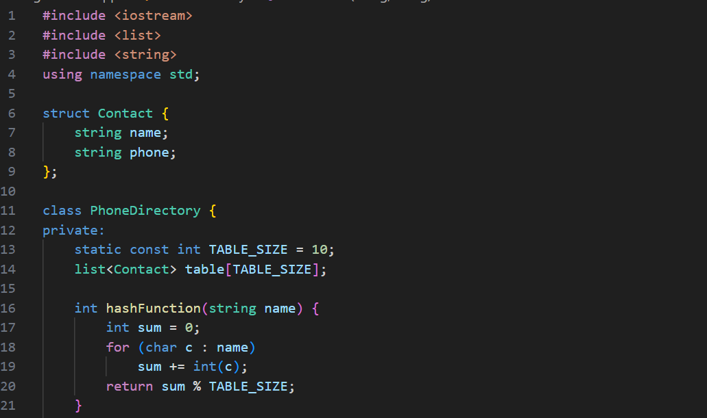
We defined a structure named Contact, also with a class – PhoneDirectory, which represents the entire phone directory.
static const int TABLE_SIZE = 10;
- This means the hash table has 10 “buckets” or slots (fixed size).
- The keyword static const ensures this value is constant and shared by all objects.
list<Contact> table[TABLE_SIZE];
- This creates an array of linked lists, where each list stores multiple contacts.
- Each index (0 to 9) represents a bucket in the hash table.
- Using list<Contact> means each bucket can hold multiple Contact objects — useful for handling collisions (if two names hash to the same index).
The hashFunction takes a name (string) and returns an index (integer) between 0 and 9, telling which bucket to use in the hash table.
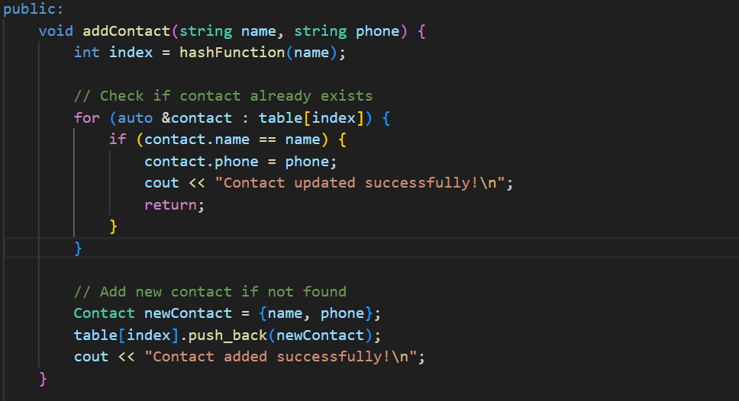
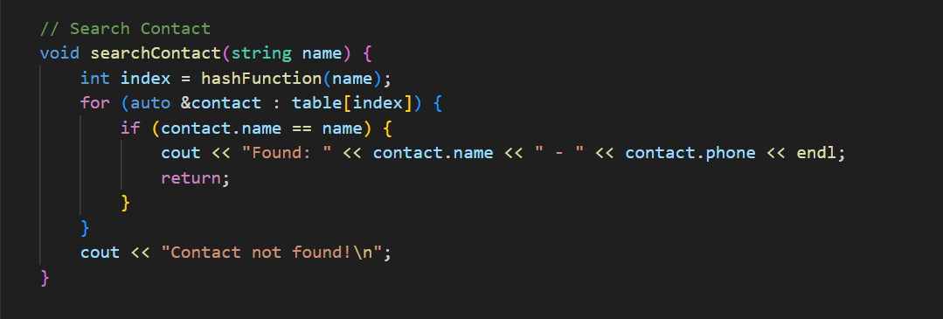
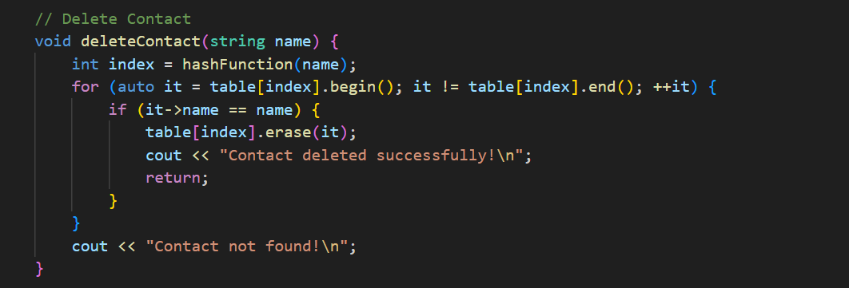
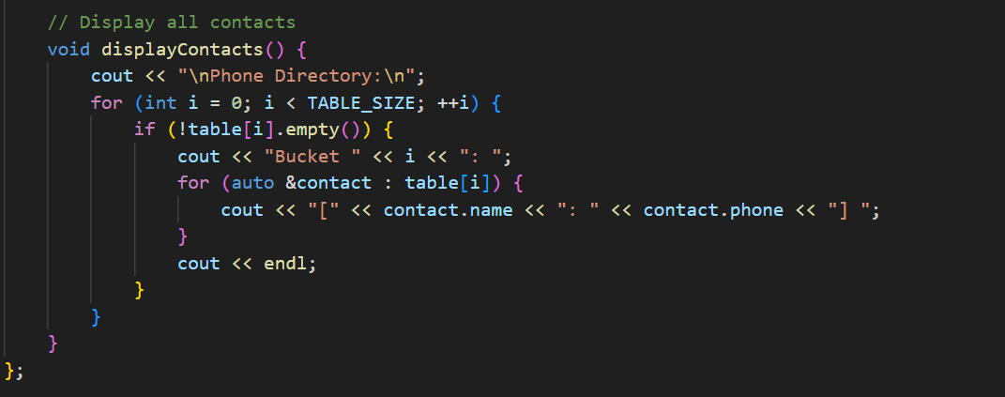
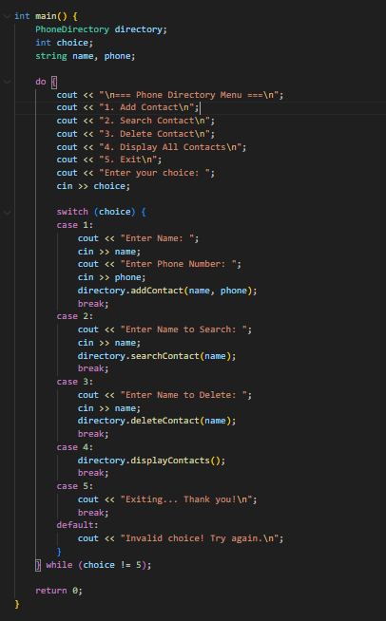
RESULTs:
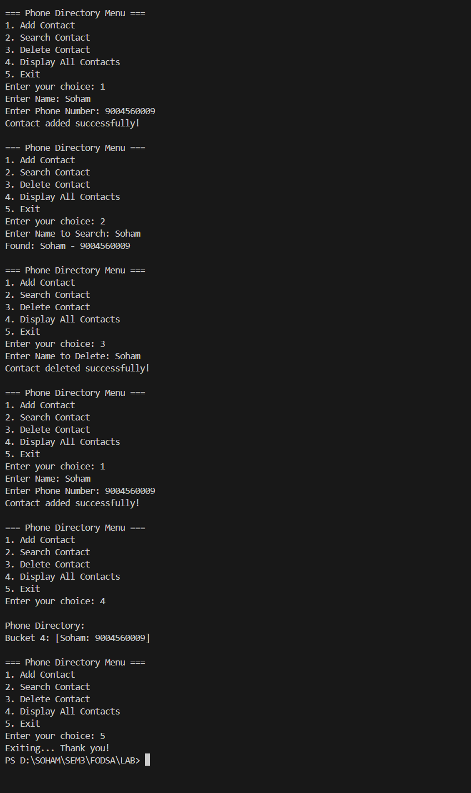

Conclusion:
In this experiment, we successfully implemented a Phone Directory System using a Hash Table and Separate Chaining collision handling.
The system allows users to efficiently perform operations like adding, searching, deleting, and displaying contacts.
The implementation demonstrates how hashing enables constant-time access and efficient data retrieval.
Through this assignment, we learned how to design an efficient data structure that is both fast and memory-optimized, making it ideal for real-world applications such as contact management systems, databases, and search engines.

